Chapter -7
From the Window
- Mention about level crossing.
Ans. A level crossing is a point where a road and railway track intersects (meet) at the same level. It is also called railroad crossing.
- Mention the safety features at a level crossing.
Ans. Due to potential danger ,a level crossing have certain safety measures when train is approaching:
  - Barriers or gates that lower or close to control road traffic when a train is approaching.
  - Warning signs.
  - Flash lights .
  - Alarms.
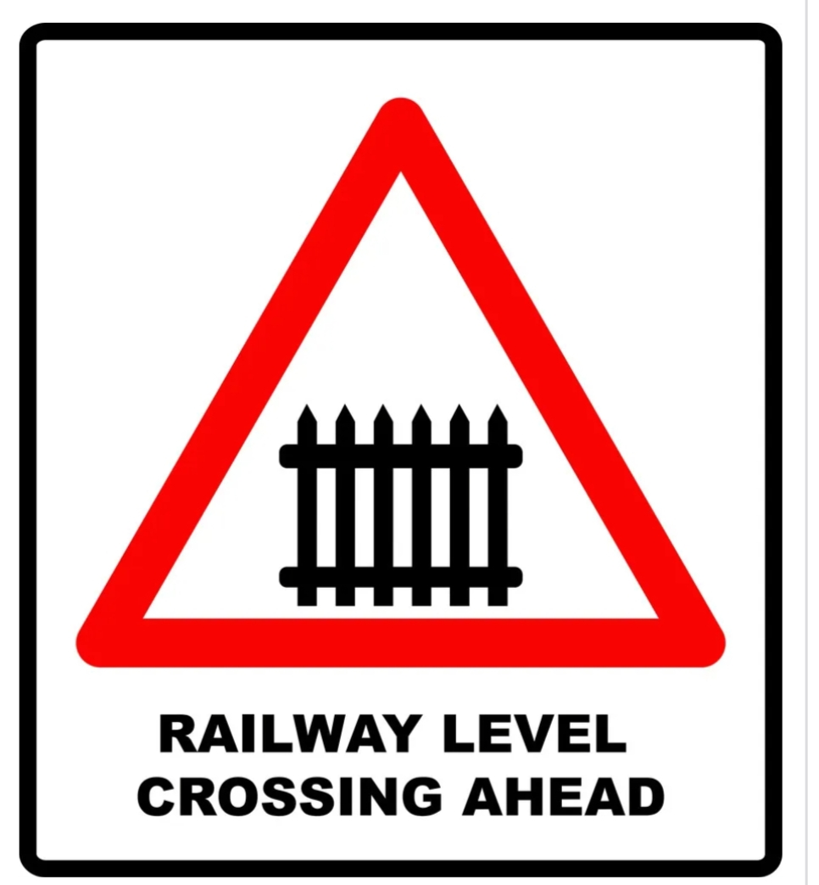
- The railway route from Goa to Kerala has 92 tunnels.
    - Explain a tunnel build through mountains.
    - Why are they made?
Ans. i). A railway tunnel is passageway that is built through the base of a mountain pass .This type of tunnel typically connect two valleys at about same heights. This tunnel is also called base tunnel.
ii)
4.Write about natural resources by giving examples.
Ans. Natural resources are resources or materiald that we get from the nature .
Example: sunlight, water,air, plants , animals,coal, minerals etc.
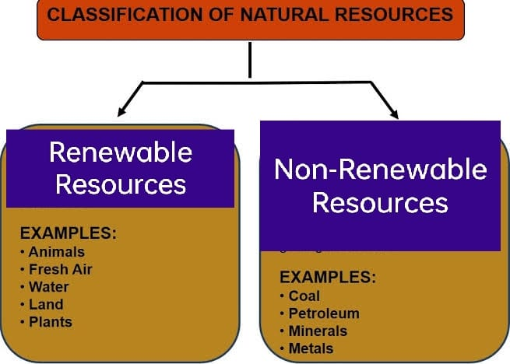
Fossil fuels: Ex. Coal, petroleum, natural gas.
Fuels formed from the remains of ancient plants and animals over millions of years.

4.Mention the differences between Renewable and Non-renewable resources with examples.
Renewable resources | Non- renewable resources
5.What steps can be taken to reduce noise of the vehicles and save petrol and diesel.
Ans.The following steps can be taken:
- Switch off our vehicle’s engine when we are waiting.
- Use public transport more and more.
- Switch to vehicles run on battery.
- Regulate the use of horns.
- Regular maintenance and servicing of the vehicles.
6.The wheels of a train rattle while crossing a bridge over a river . Can you mention the reason.
Ans. The wheels rattle as there is no ground,only the tracks and the water down below. The sound is produced because of t he lateral movement of the wheels and subsequent connection with the tracks.
7. Write the difference between railway bridge and normal cement bridge.
Ans.
 | Railway bridge | Normal cement bridge
Purpose | 1.Carry railway tracks and train over rivers, valleys,other roads. | 1. To provide a road surface for vehiclesor pedestrians.
Design | 2. Designed to carry heavy loads of train and sustain vibrations. | 2. Withstand the weight and traffic of various road vehicles.
Maintenance | - Often require specialized maintenance and inspections. | 4.Require good maintenance.

Home work worksheet
8.Madgaon is in the state of___________.
9.Udipi is in state of __________.
10. Kottayam is in the state of ________.
11. Sometimes people cross the railway tracks when the level crossing is closed. What do you feel about this?
12.Name three vehicles each, which runs on-
a) petrol
b) diesel
13.Diesel and petrol need to be saved. Why?
14.Write 4 things that you can learn from traveling by train.

